Fall 2022   
Derek Stearns  
CSCI 4150/8156   
Homework Two

1. (6 pts) The following graph represents houses and their connections in a given neighborhood. A cable company would like to find the least expensive way to connect the houses using cables so that all houses can be reached.   
a. If it costs the same to connect any two houses in the neighborhood, what is the equivalent graph problem to the original cable connections problem?

It becomes a center of the graph problem, or spanning tree problem, if the costs are the same to connect any two houses as finding the center represents finding the smallest-largest cost of any trail in the graph.

b. If the weight of an edges connecting two houses in the figure represent how expensive it is to install cable between the two houses, what graph problem would accurately model the cable connection problem.

Minimum-Cost Spanning tree would help find the least costly routes for the graph of housing cables

c. What known algorithms that can be used to solve the problem of part b? Identify at least two.

Kruskal and Prim’s algorithm would enable a person to find the least expensive way to connect the houses.

d. What is the optimal cost for this neighborhood to install the cable? Apply one algorithm and show your steps.

Starting with the graph completely empty and starting the smallest weight we will add it (as long as it doesn’t create a cycle) until all nodes have been added.

1. Start with (A,g) +1 (1)
2. Add (C,B) +2 (3)
3. Add (D,F) +3 (6)
4. Add (B,F) +4 (10)
5. Add (A,B) +5 (15) The answer is 15.

2. (6 pts) A company wants to analyze how well the various pages of their website are set up. To achieve this objective, a graph model is proposed that connects two web pages if one page has a link to another webpage in the site. Recent research has shown that 4 is the maximum number of clicks a user would like to go through to classify a website as easily navigable.

a. Using this graph model, what graph property or parameter can be used to determine if a company’s website is easily navigable for users?

The eccentricity of a node can be used to evaluate the radius of the graph from any given point to fit the requirement of a total of four clicks (nodes) from the entrance.

b. If there are several pages can be used as the main page of the site, what graph property that can be used to determine which web page is a good choice for the site’s home page?

The center of the graph can be used for a good choice for a home page as it should have the minimum centricity.

c. Show a simple example of pages of a website that is easily navigable and has only one option for a home page.

In this example, B should be the homepage.

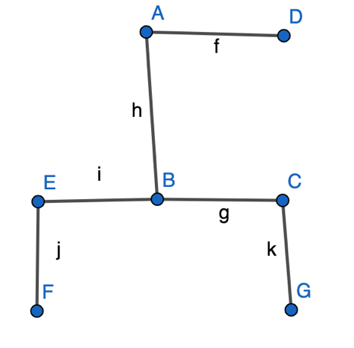

d. Show a simple example of pages a website that is not easily navigable and has more than one option for a home page.

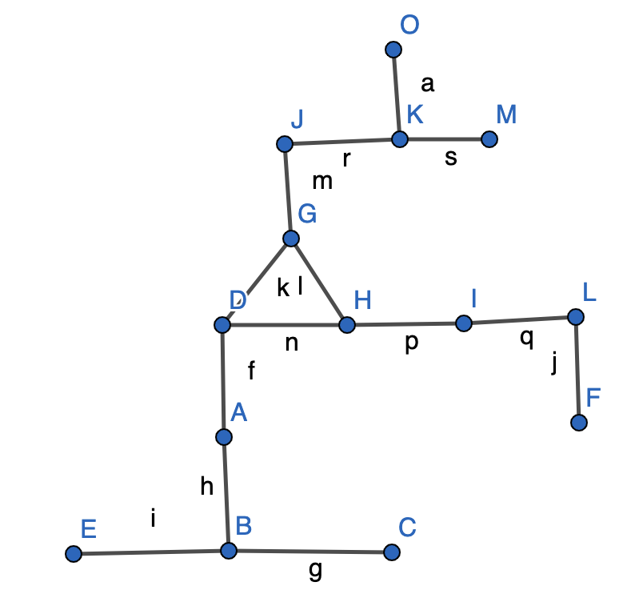  
  
3. (3 pts) Find a labeled tree corresponding to each of the following Prufer Sequence:   
a. (1,1,1,2,6,5)

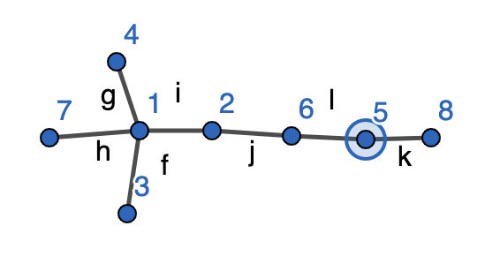  
b. (5,1,1,4,5,5)

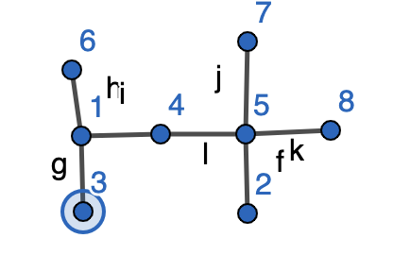  
c. (1,2,3,4,5)

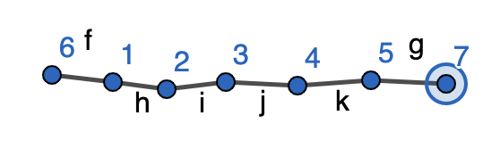  
  
  
4. (3 pts) Due to budget cuts a new work model has to be determined for the fire department in which a fire fighter has to play more than one role from the three roles needed in any dispatch to fight a fire. In order for a truck to qualify to fight a fire each needs one medic, one driver and one chief. The following fire department employees, represented by E1, E2, ..., E8 have the associated qualifications:   
E1 = {Chief}, E2 = {Medic, Chief}, E3 = {Medic, Driver}, E4 = {Driver},   
E5 = {Medic}, E6 = {Medic, Driver}, E7 = {Driver}, E8 = {Chief}   
a. Suggest an appropriate Graph Model that depicts the roles of the fire fighters in the departments and simplify the problem of identify a valid truck team.

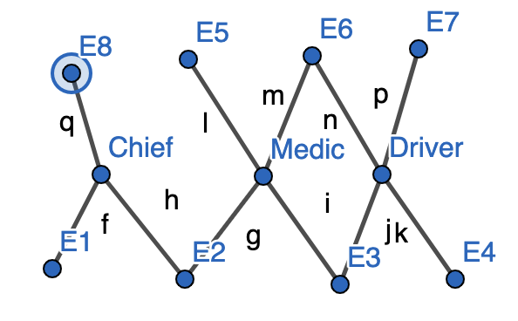

b. Determine how to select a proper team from the available members at a given time?

By using a task graph and finding the maximum independent sets, we can find a number of teams by ensuring a trail of 6 nodes; or a group of disconnected components or a tree that includes each role.

c. If all members are present, how many fires this group qualifies to fight at one time. In other words, how many simultaneous fires can be dealt with by this fire department?

2. 8 /3 = 2 + remainder  
  
5. (2 pts) Find a tree corresponding to each of the following Degree Sequence:   
a. (5, 2, 2, 1, 1, 1, 1, 1)

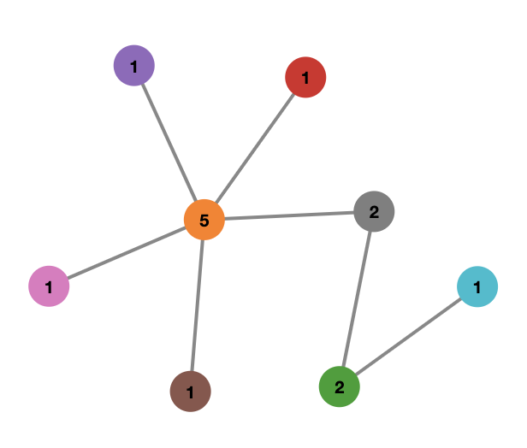  
b. (5, 2, 2, 2, 2, 1, 1, 1)

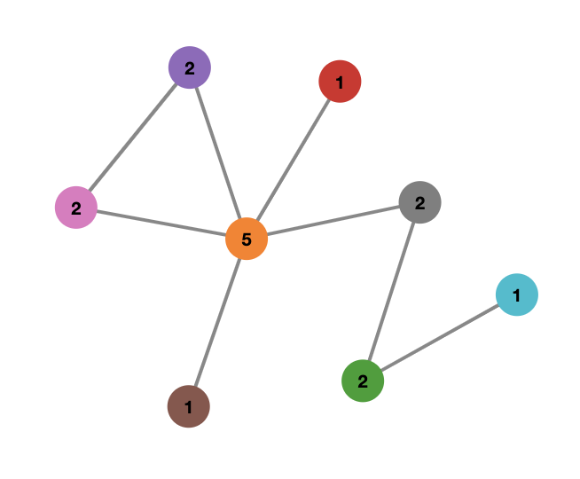  
  
6. (5 pts) For the graph below, label the vertices going clockwise starting with the left most node and answer the following questions:   
a. (2 pts) Specify the distances between all pairs of nodes.   
b. (3 pts) Identify the eccentricities of the nodes and the radius, diameter, the center, and the weighted center of the graph.   
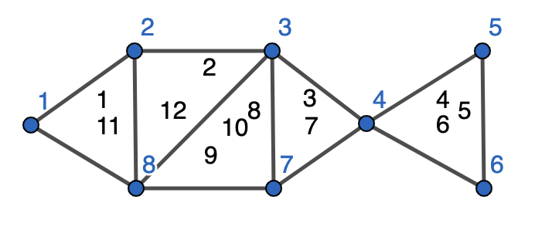

Distances:

(1,2;1,8;2,8;8,3;2,3;8,7;3,7;7,4;3,4;4,5;4,6;5,6) 1

(1,3;1,7;2,7;2,4;3,6;7,5;7,6) 2

(1,4;2,6;2,5;8,6;8,5) 3

(1,6;1,5) 4

Eccentricities:

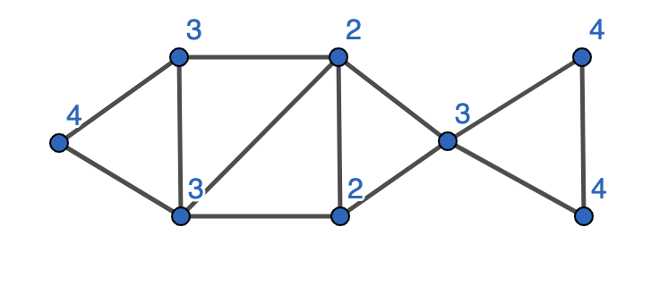

The radius is 2, the diameter is 4 and the center is vertices 3 & 7. The weighted center is   
  
  
7. (3 pts) What is the number of Spanning Trees of K2,3?

12  
  
8. (2 pts) Give an example of a tree where the diameter is not twice the radius. Under what conditions are the diameter and the radius the same?

Here the diameter is 5 and the radius is 3. The radius will equal the diameter when the center of the graph includes the nodes of the diameter and the center is a self-center.

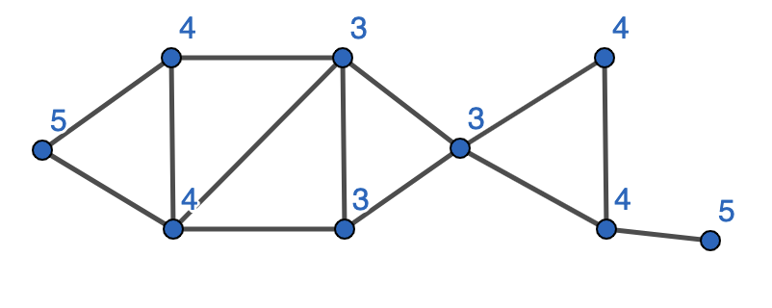  
  
  
Due on Thursday 9/22/2022